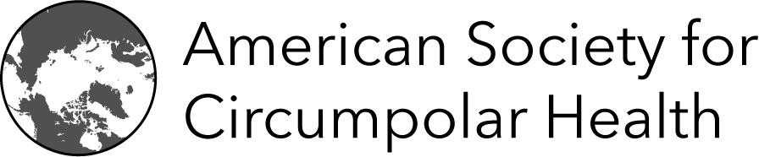
CALL For Presentations
2024 Annual Meeting, Friday, March 29th, 2024
What? The American Society promotes health advances in the Circumpolar North. We are part of the International Union for Circumpolar Health, with members in all Arctic nations. The International Congress on Circumpolar Health (ICCH18) will be in Yellowknife, Canada, June 18- 20, 2024.
The American Society has funding to support travel for presenters to the ICCH. In addition, The Arctic Health Foundation will provide the Albrecht Milan Emerging Professional Award to one of the presenters at our Annual Meeting (a cash award!).
When? Friday, March 29th, 2024; 12:00-4:30pm (AK Time),
12:00 - 1:00. Lunch and American Society business meeting.
1:00 - 4:30. Presentations and discussion
Where? UAA Campus, Professional Studies Building, Room 166 (Address: 2533 Providence Drive, next to Wendy Williamson Auditorium). Online access via Zoom
Why? Hear the latest on Arctic Health Sciences research and join this informal opportunity to present your work before peers. New investigators and graduate students are encouraged to present!
Learn about the American Society and the International Congress of Circumpolar Health Learn about funding opportunities to attend ICCH.

How? RSVP. Tell us that you plan to attend (in-person, or via Zoom) by sending an email to Ruby Fried (rlfried@alaska.edu)
Sign up to be a presenter. Submit a 300 word abstract to [ rlfried@alaska.edu ] to apply for a 15-minute oral presentation. Due March 22, at close of business. Include contact information (email, phone number). Presentations via Zoom are welcome. Poster presentations are also available.

For More Information Contact:
Ruby Fried at rlfried@alaska.edu

